**Develop the problem under consideration**.

**Crop prediction**

Contents:

1. Problem Statement:

Crop Yield Prediction involves predicting yield of the crop from available historical available data like weather parameter, soil parameter and historic crop yield.

The existing method of soil classification and crop suggestion require manual involvement, human errors, and the results are uncertain. The method is also time consuming and invasive in nature. But our proposed system overcomes all these errors because it takes into account the physical properties of soil for classification and prediction.

1. Objectives
2. The main goal of this project is to classify soil series.
3. As well as to predict suitable crop. And detect the Soil Type.
4. Motivation

key motivation for developing this project is as we say every part of world is developing but we can see that there is no such big achievement or development in soil or crop related issues. So we can give preference to this soil field and if we suggest suitable crop to farmers then it is beneficial for them. And also main motivation is to minimize the time required for the surveying process which leads to delayed insurance claims.Develop a farmer friendly chat bot to ask queries.

**Justify feasibility assessment using NP-Hard and NP-Complete.**

Contents:

1. Algorithm Used

Convolutional Neural Networks specialized for applications in image & video recognition. CNN is mainly used in image analysis tasks like Image recognition, Object detection & Segmentation.

There are Four types of layers in Convolutional Neural Networks:

1) Convolutional Layer: In a typical neural network each input neuron is connected to the next hidden layer. In CNN, only a small region of the input layer neurons connect to the neuron hidden layer.

2) Pooling Layer: The pooling layer is used to reduce the dimensionality of the feature map. There will be multiple activation & pooling layers inside the hidden layer of the CNN.

3) Flatten: Flattening is converting the data into a 1-dimensional array for inputting it to the next layer. We flatten the output of the convolutional layers to create a single long feature vector.

4) Fully-Connected layer: Fully Connected Layers form the last few layers in the network. The input to the fully connected layer is the output from the final Pooling or Convolutional Layer, which is flattened and then fed into the fully connected layer.

1. Mathematical Model

Let S be the Whole system S= {I, P,O}

I - input

P - procedure

O - output

Input( I)

I={ Input as soil image Dataset }

Where,

1. Dataset contain Soil images dataset.

Procedure (P),

P= 1. Train the dataset (Soil image dataset)

2. Pre-processing

3. Feature Extraction

4. Segmentation

4. Classification (used CNN algorithm)

5. Create Model.

Output (O)-

O= 1. System detect Soil type.

2.Predict the suitable Crop.

1. Algorithmic Analysis (NP-Hard, NP-Complete)

**What is NP?**

* "NP" means "we can solve it in polynomial time if we can break the normal rules of step-by-step computing".

**What is NP Hard?**

A problem is NP-hard if an [algorithm](http://mathworld.wolfram.com/Algorithm.html) for solving it can be translated into one for solving any [NP-problem](http://mathworld.wolfram.com/NP-Problem.html) (nondeterministic polynomial time) problem. NP-hard therefore means "at least as hard as any [NP-problem](http://mathworld.wolfram.com/NP-Problem.html)," although it might, in fact, be harder.

**Np-Hard:**

A CG which is based on word-graph is constructed to organize all information in a sentence cluster, CG can reduce the size of graph and keep more semantic information than word-graph. We use beam search and character-level RNNLM to generate readable and informative summaries from the CG for each sentence cluster, RNNLM is a better model to evaluate sentence linguistic quality than n-gram language model. the system with CG can generate better summaries than that with ordinary word-graph.

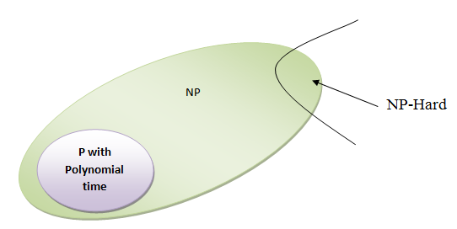

**What is NP-Complete?**

* Since this amazing "N" computer can also do anything a normal computer can, we know that "P" problems are also in "NP".
* So, the easy problems are in "P" (and "NP"), but the really hard ones are *only* in "NP", and they are called "NP-complete".
* It is like saying there are things that People can do ("P"), there are things that Super People can do ("SP"), and there are things *only* Super People can do ("SP-complete").

**NP-Complete:**

As our system is in developing state so we can’t say that our system is currently in NP complete state

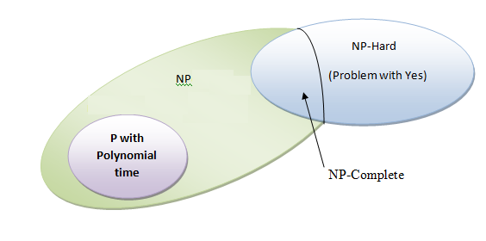

**Design Architecture modules of your project**.

Contents :

1. Architectural Diagrams

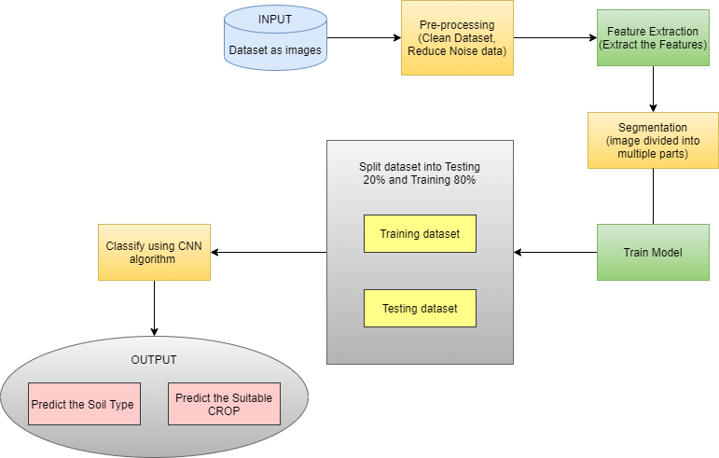

* We need to know the features and characteristics of various soil types to understand which crops grow better in certain soil types.
* Machine learning techniques can be helpful in this case.
* Then apply apriority Mining process to generate an association rule for finding suitable crops for the specific soil.
* Soil series and land type combine represents the soil class in the database.
* The machine learning methods are used to find the soil class (i.e. soil series and land type). Algorithm are used: CNN.

1. Modules

* Image Selection : We have to select data as our dataset and provide it to the system which we have to trained.

* Pre-processing : Image preprocessing are the steps taken to format images before they are used by model training and inference. This includes, but is not limited to resizing, orienting, and color correction.
* Feature Extraction : Feature extraction refers to the process of transforming raw data into numerical features that can be processed while preserving the information in the original data set. It yields better results than applying machine learning directly to the raw data.
* Segmentation : Segmentation, the technique of splitting customers into separate groups depending on their attributes or behavior, makes this possible.
* Classification : CNNs are used for image classification and recognition because of its high accuracy. The CNN follows a hierarchical model which works on building a network, like a funnel, and finally gives out a fully-connected layer where all the neurons are connected to each other and the output is processed.